1. Argus Login page <https://mqtt.eurozapp.eu/argus/login>

By using User name and password you can Enter the Dashboard page.

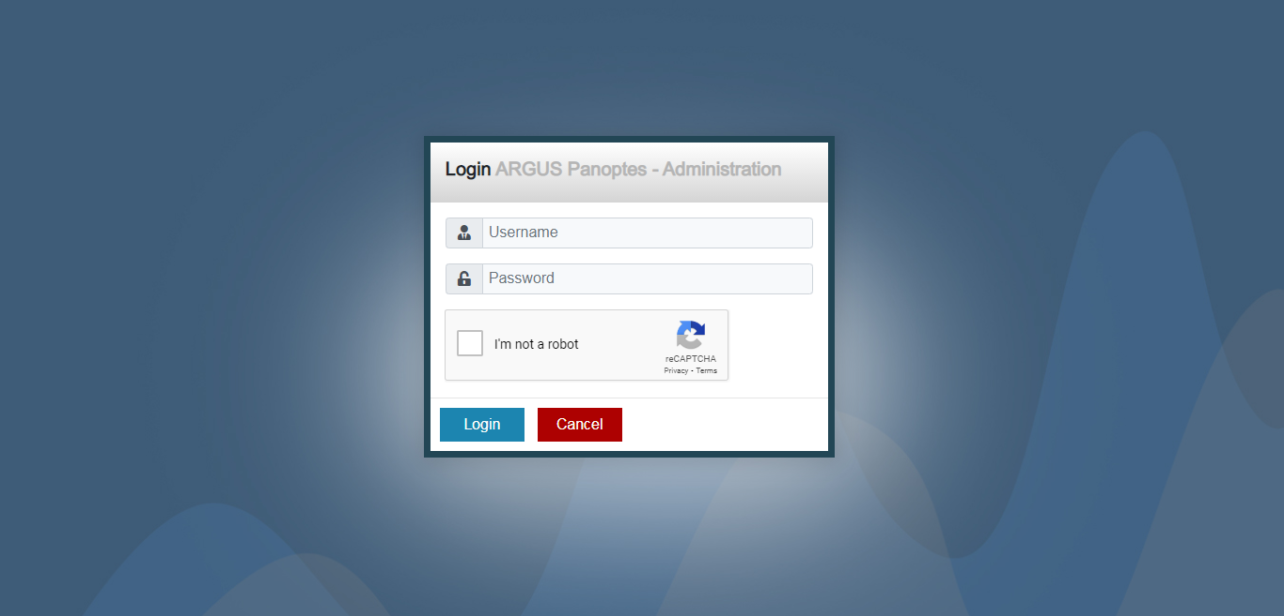

1. Once you Login in the dashboard, the page will be look like below image.
2. In the dashboard page you can see the total number of Agent, Gateway Group, Hubs and Sensors you created.
3. In the Agent Log, you can monitor Agent login and Logout time status.
4. In the Console table you can trace all sensor reading.

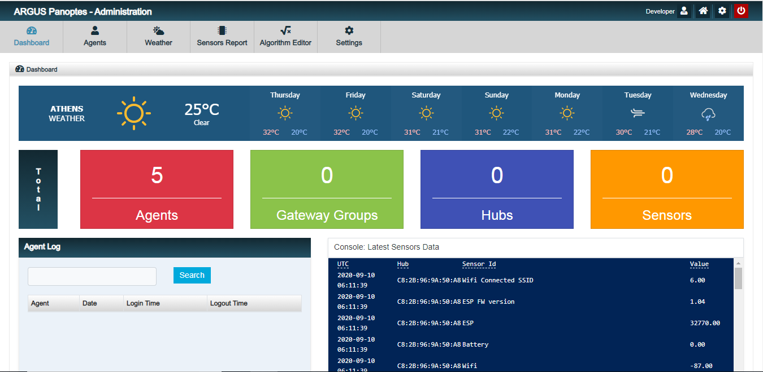

1. Agents: In the top menu click on the Agent button. See the below screen shot,

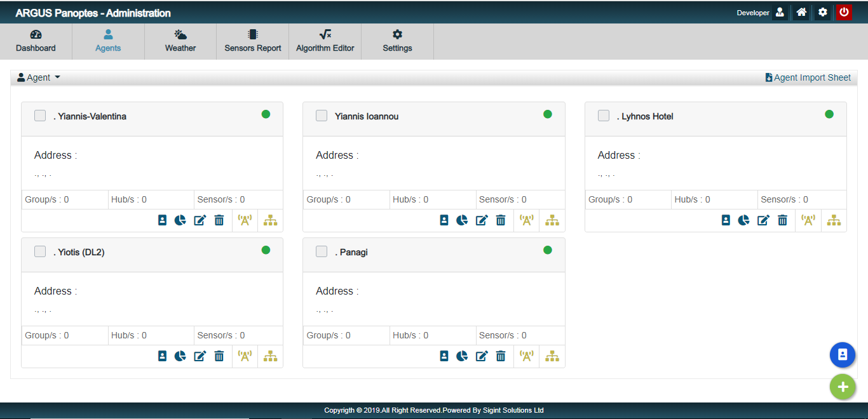

1. Add agents by press the plus button at bottom right corner . On click the plus button a popup form you can enter agent details then click on save. Once you save the details, the agent will appear in the screen.
2. If you need to import bulk of agent then import the bulk agent as excel file. In the top header there is a button Agent Import sheet by click that button you can download a excel template then you can import by click the right corner button .
3. From here we can import Gateway group for single Agent and multiply agent you can select the check box at top profile card. Dowload Gateway group import sheet from top header. Then import the Gateway group excel by click bottom right  button.
4. You view the Agent profile by click on the profile Icon in the agent card .
5. If you need to check the Agent dashboard just click on the dashboard icon .
6. Need to edit any agent you can click the edit icon .You can set agent active and Inactive. The active agent in card it will show green  and Inactive it will show as red .
7. If you need to edit bulk agent at same time the you can easly select the agent by click at the check box then click at export button at bottom right  . After edit the excel you can import the agent.

 

1. For delete agent click delete icon . If you need to delet more agent you can select agent by click checkbox in the bottom right click delete button .
2. In the profile card the is a option to look all the assigned Gateway group, Hubs and Sensor in tree structure. There is a button name as Visual Hierarchy by click it you can get a screen like below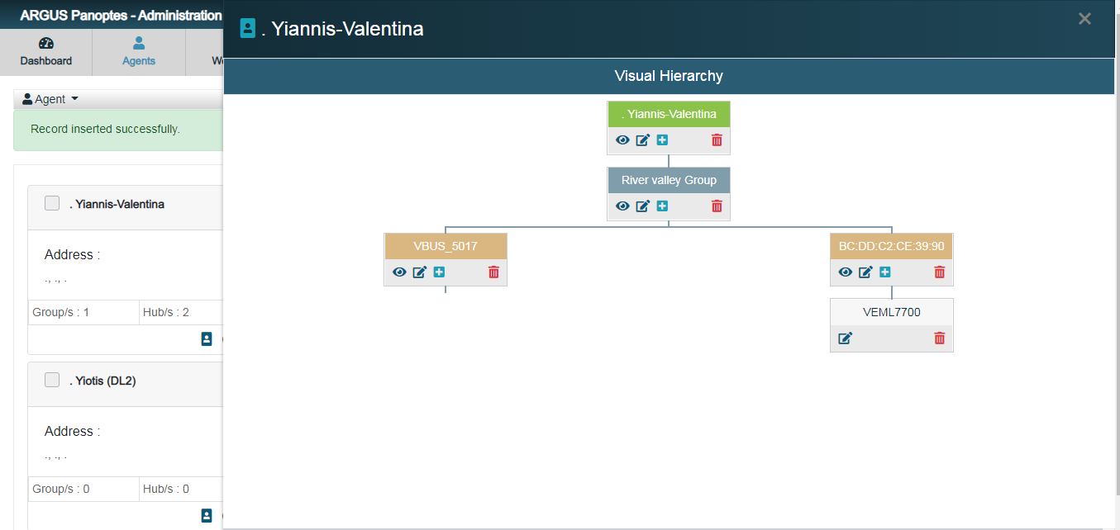
   1. You can Add , Edit and you can also delete Gateway group, Hubs and sensor from here.



1. Click on the Group Icon in agent profile card you can go to Gateway group page look like

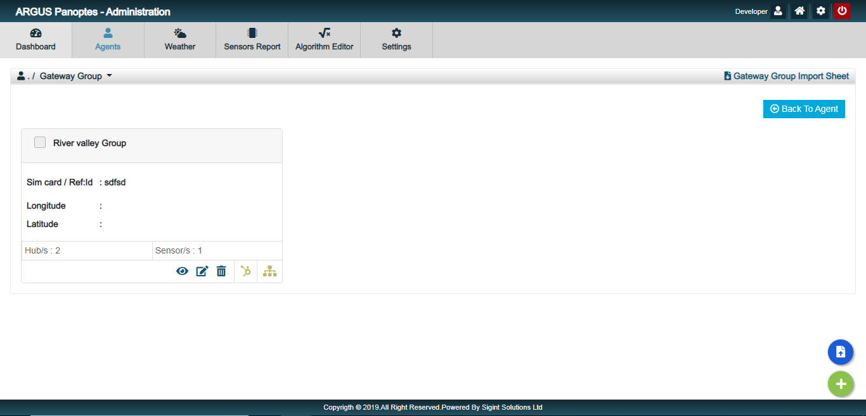

1. Add Gateway Group by press the plus button at bottom right corner . On click the plus button a popup form you can enter Group details then click on save. The saved Group will appear in the screen.
2. In the Gateway group popup screen you can add Gateway group Name by click the plus button near Gateway group name dropdown. So no need to go on setting page for create a name. It will save your time.

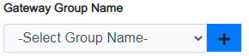

1. If you need to import bulk of Gateway Group then go to the top header there is a button Gateway group Import sheet by click that button you can download a excel template then you can import by click the right corner button .
2. From here we can import Hubs for single Gateway Group or multiply Gateway Group. For this you can use the same methods as agent page.
3. You can View and edit the Gatway Group by click .
4. For edit click edit icon .
5. For delete Gateway Group click delete icon . If you need to delet more group - use the same methods as agent.
6. Visual Hierarchy  same as agent but here we show tree from Gateway group.
7. Click Hubs Icon  from the Gateway group card. You can enter Hub create the Page looks like

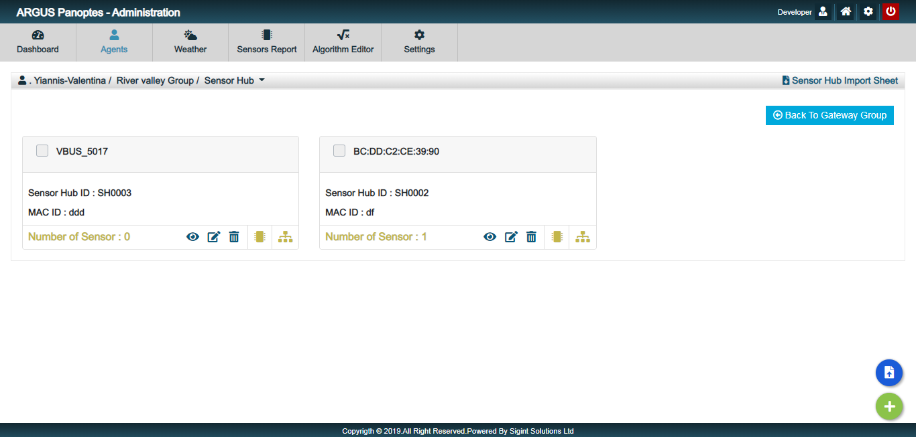

1. Add Hubs by press the plus button at bottom right corner . Same as gateway group methods
2. If you need to import bulk of Hubs – same as gateway group methods
3. You can View and edit the Hubs by click .
4. For edit click edit icon .
5. For delete Gateway Group click delete icon . If you need to delet more group use the same methods as gateway group.
6. Visual Hierarchy  same as agent but here we show tree from Hubs.
7. Click sensor Icon  from the Hubs card. You can enter Sensor create the Page looks like

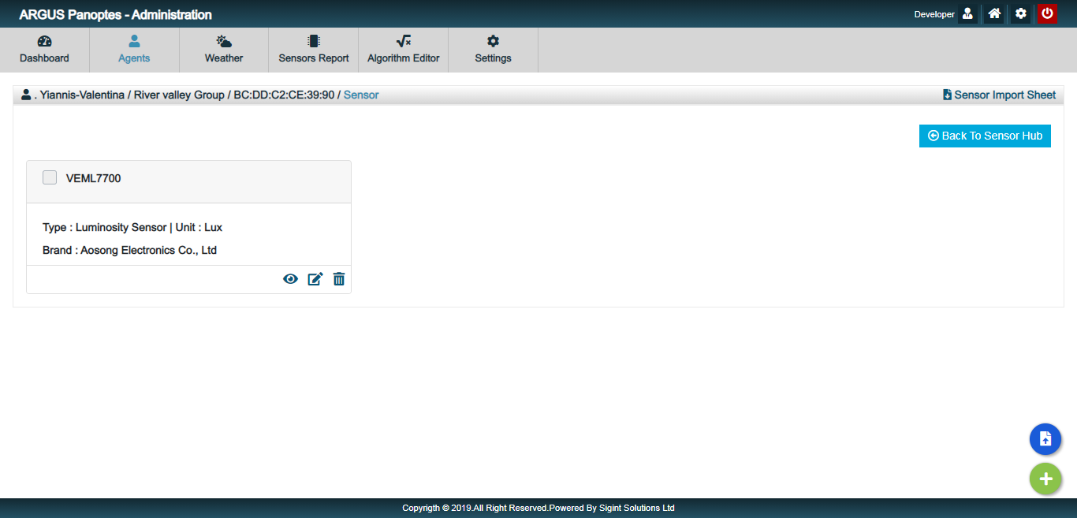

1. Add Sensor by press the plus button at bottom right corner . Same as Hubs methods
2. If you need to import bulk of Sensor – same as Hubs methods
3. You can View and edit the Sensor by click .
4. For edit click edit icon .
5. For delete Sensor click delete icon . If you need to delet more group use the same methods as Hubs.
6. In the menu click on the weather link

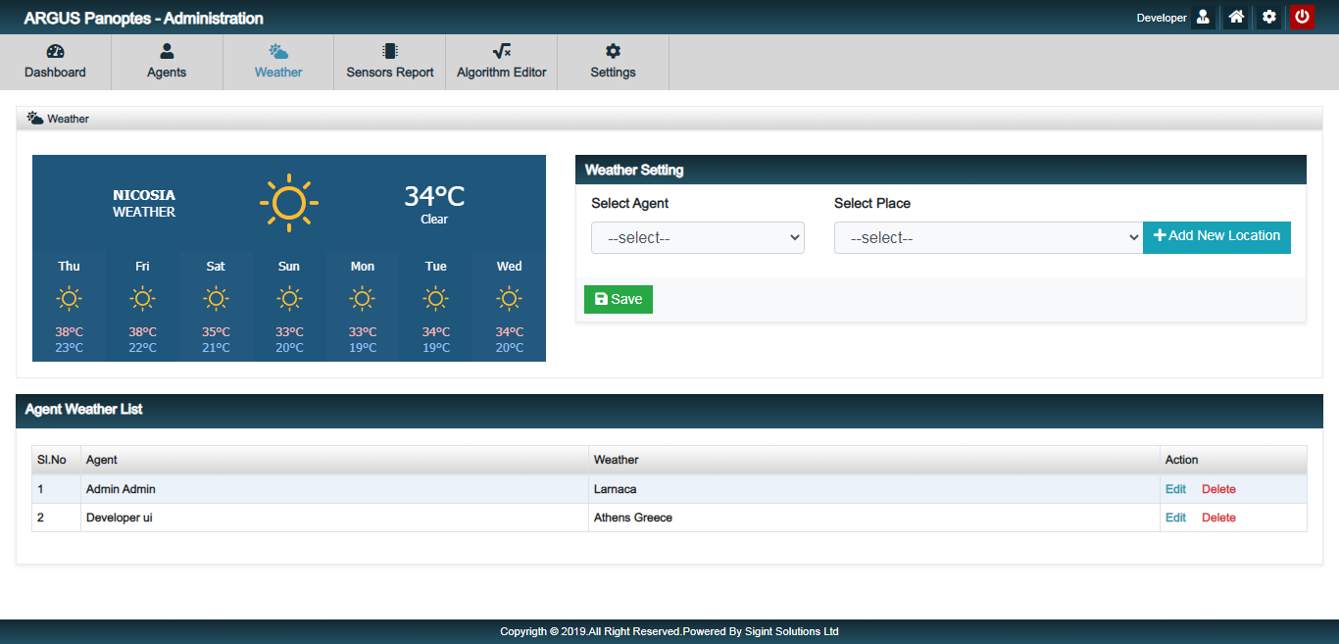

1. In this page we can assign weather for different agent. The assigned weather will appear on the agent dashboard. Select agent and select the place you need as weather then click on save.
2. The add location button used for add some new location as your need. The screen look like

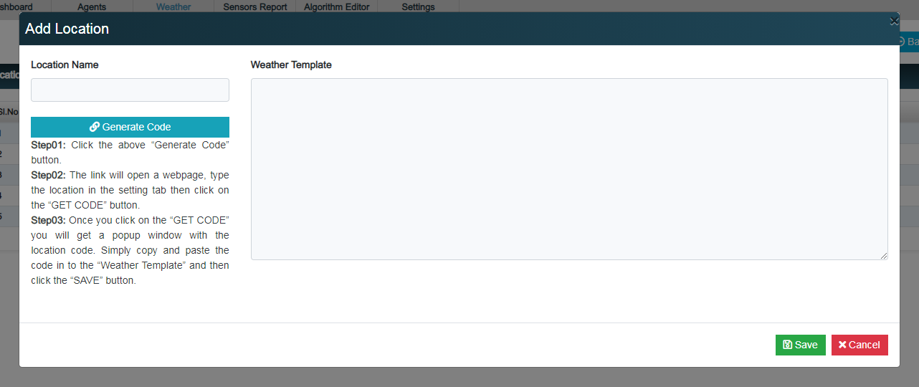

i. Enter location name, Generate code form the link given. Copy and past the code you generated and save the template. The location will added in list.

1. By Sensor Report menu you can go to the page
   1. Sensor Time Report – Here we select one agent, Multiply Gateway group, Multiply Sensor Hubs, one Unit and only three sensors and the time stamp as your choice.
   2. You can see the result as table format and Graphical format. In the graphical report you can choose different chart based on your wish.
   3. You can export data in excel format by click on export button. 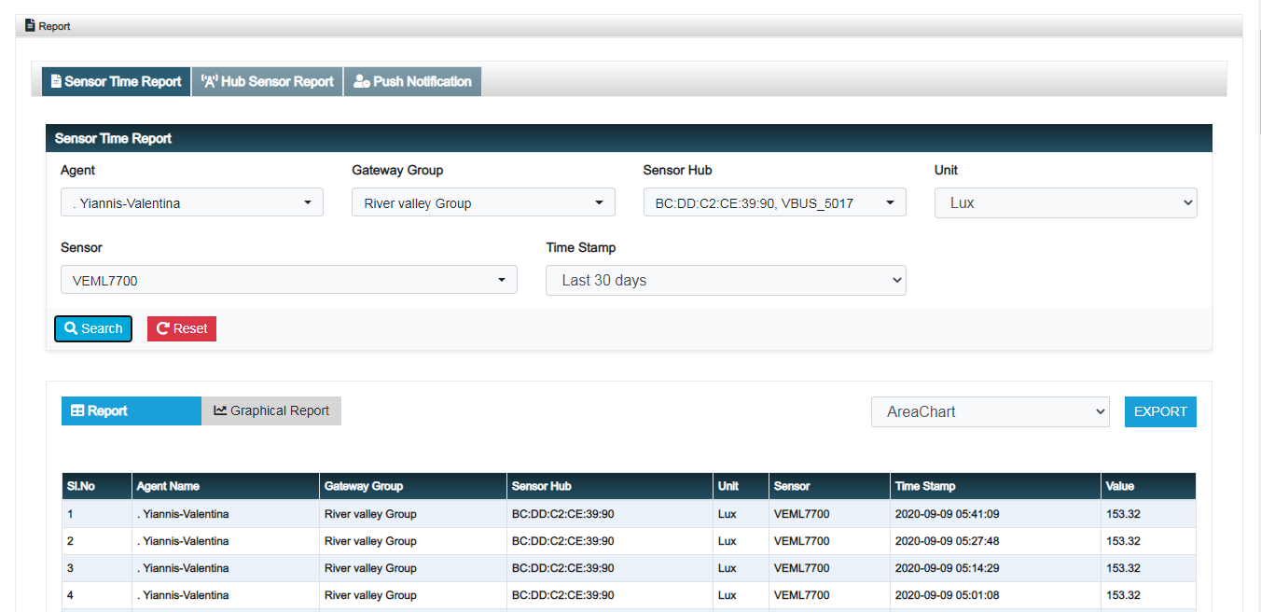

* 1. Hub Sensor Report – Here all items need to select as single. you can see the result as table and graphical report.
  2. You can export data in excel format by click on export button.

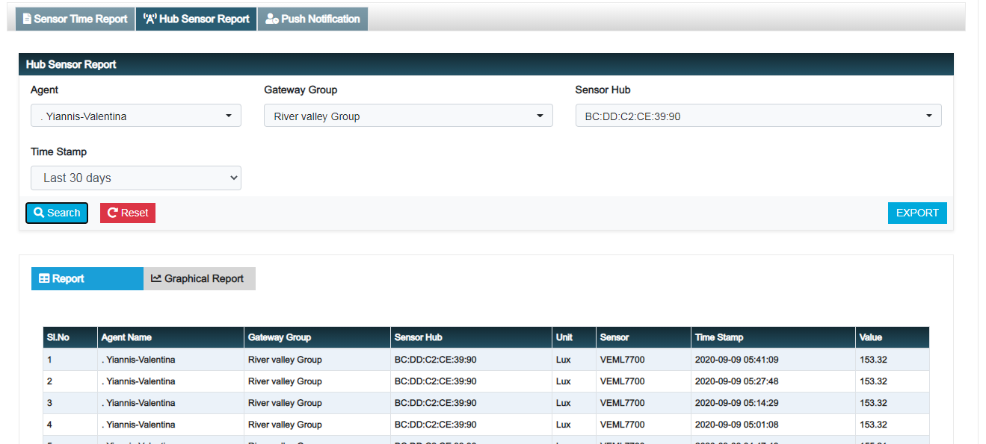

* 1. Push notification – All the assigned algoritham push notification need will show in the table.

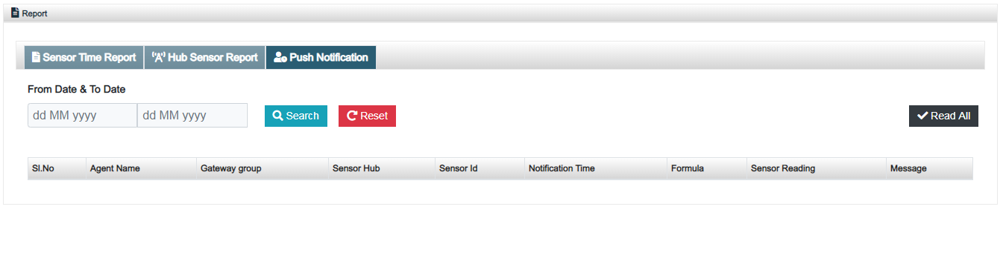

1. By click Algorithm Editor – go on add algorithm

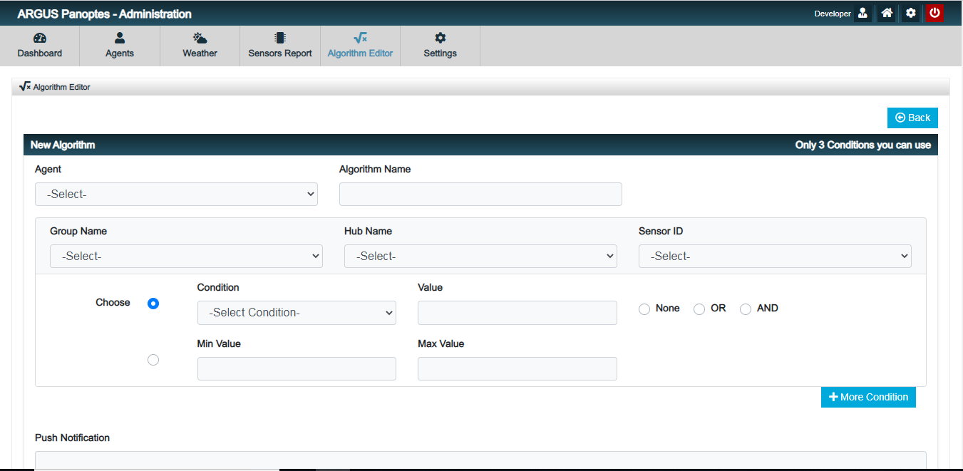

1. Here we can add only three condition.
2. Select agent, Type algorithm name , Select Gateway group name, Select Hub Name, Select sensor Id and now choose condition
   1. First Method – In drop down we have different formula such as <, >, <= , >= , == we can select any formula then enter value and then select None, OR, And.
      1. If we select None then we can’t able to add more condition.
      2. If we select OR , AND we can choose more condition.
   2. Second Method – Min and Max value
3. Setting page

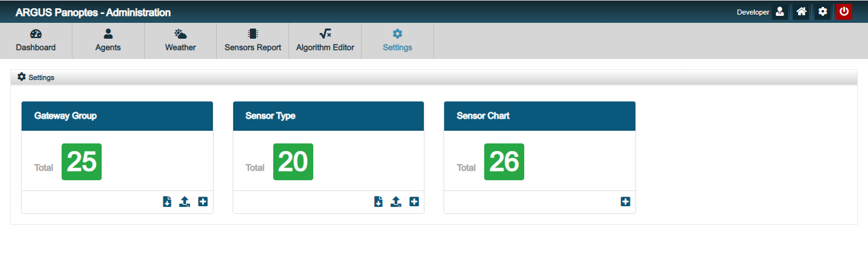

1. Here we Add Gateway group name, Sensor type and Sensor chart.
2. By click the plus button  the form will appear in screen you can enter the detail and save.
3. For bulk import first you need to down load the excel template by click download icon .Then you can import the excel through import button .
4. System setting by click 
5. Email – You can set email template for agent and admin.

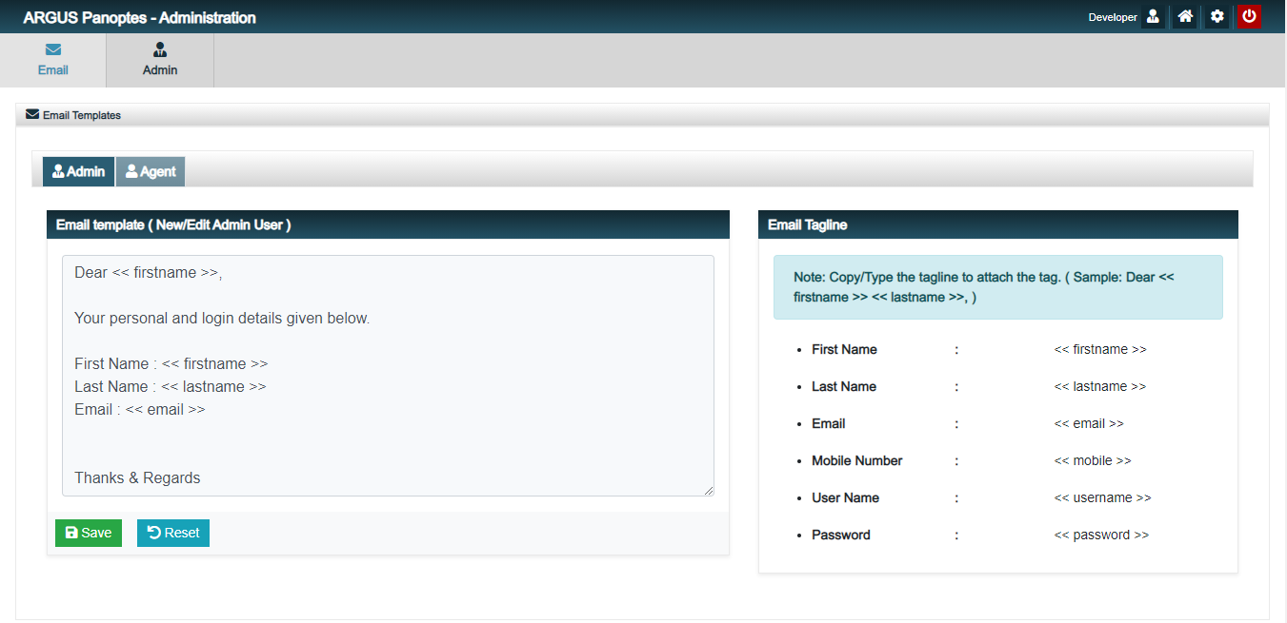

1. Admin – by click add new admin you can create admin.

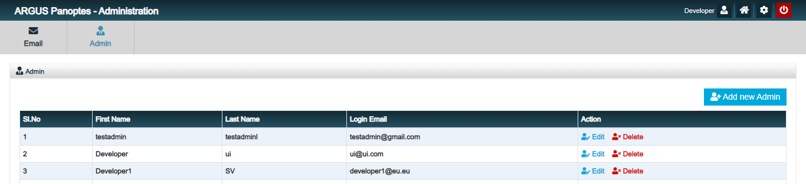

1. If you need to go back to the dashboard just click on the Home button It will take you dashboard. 

*Completed*